

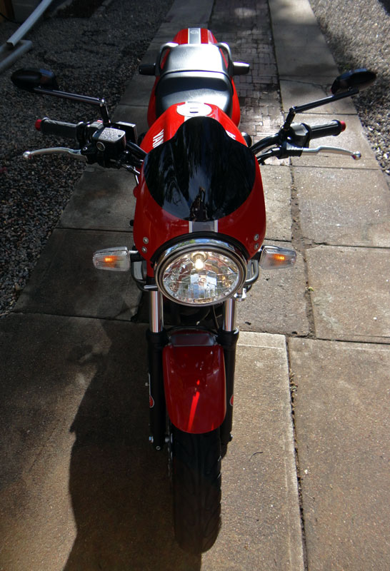


2013 Wall Calendar
SunMonTueWedThuFriSat12345678910111213141516171819202122232425262728293031
2013
January

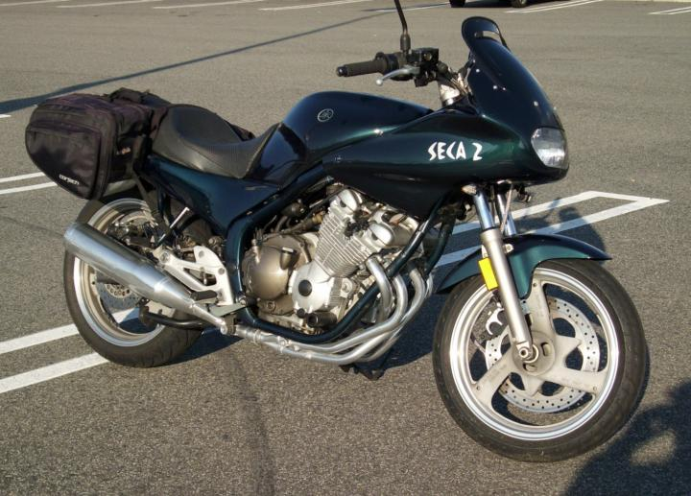
1Oldman’s 1993 XJ600S (Seca II)

SunMonTueWedThuFriSat12345678910111213141516171819202122232425262728
2013
February

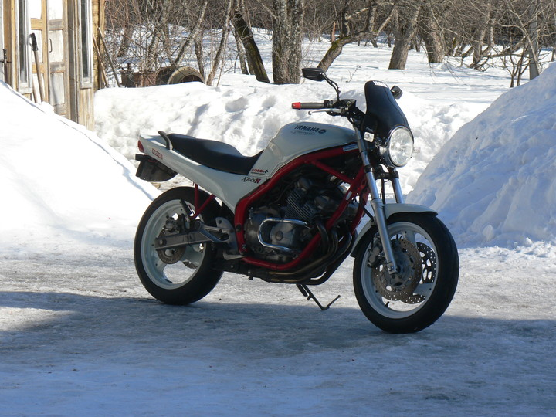
Siniraag’s 1993 XJ600N

SunMonTueWedThuFriSat12345678910111213141516171819202122232425262728293031
2013
March

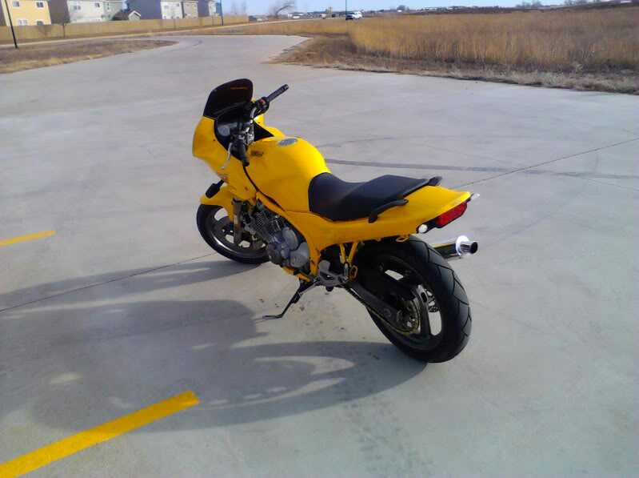
Seca2’s 1994 XJ600S (Seca II)

SunMonTueWedThuFriSat123456789101112131415161718192021222324252627282930
2013
April

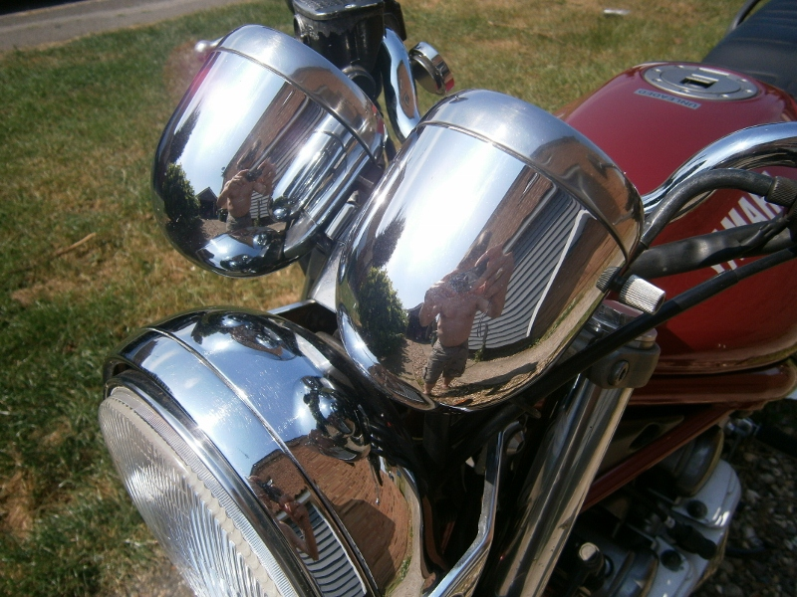
Mikee112’s 1999 XJ600N

SunMonTueWedThuFriSat12345678910111213141516171819202122232425262728293031
2013
May

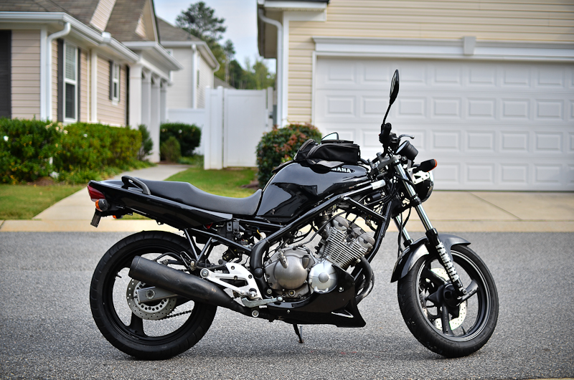
Drapheus’ 1995 XJ600N

SunMonTueWedThuFriSat123456789101112131415161718192021222324252627282930
2013
June

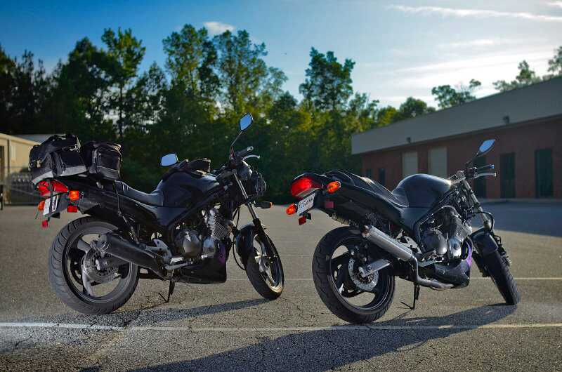
Oizarod115’s 1992 XJ600N

SunMonTueWedThuFriSat12345678910111213141516171819202122232425262728293031
2013
July

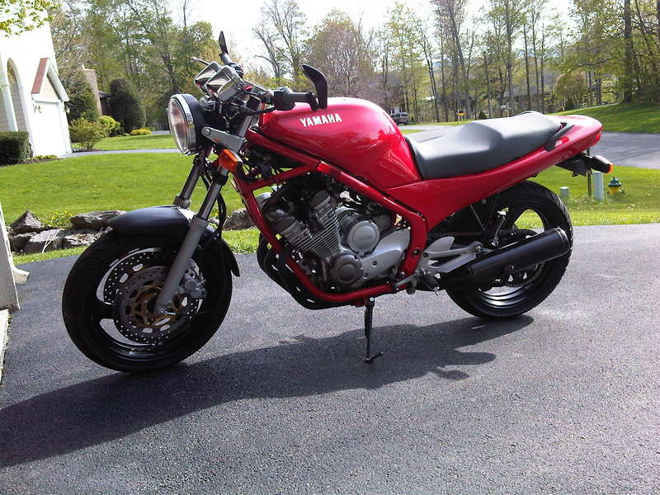
RDBluesmoke’s 1993 XJ600N

SunMonTueWedThuFriSat12345678910111213141516171819202122232425262728293031
2013
August

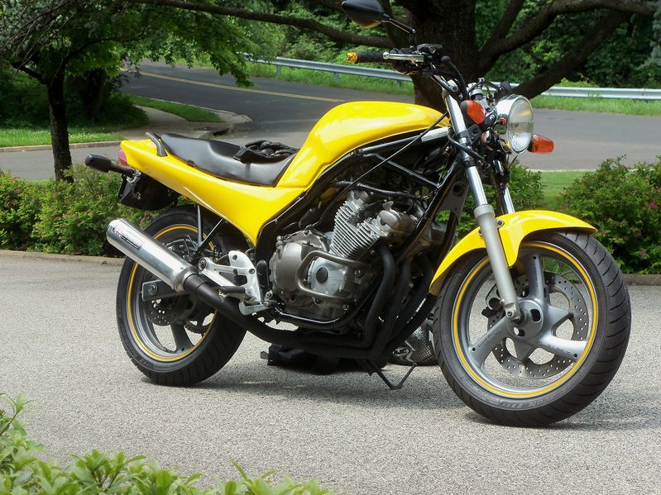
Super Mario’s 1992 XJ600N

SunMonTueWedThuFriSat123456789101112131415161718192021222324252627282930
2013
September

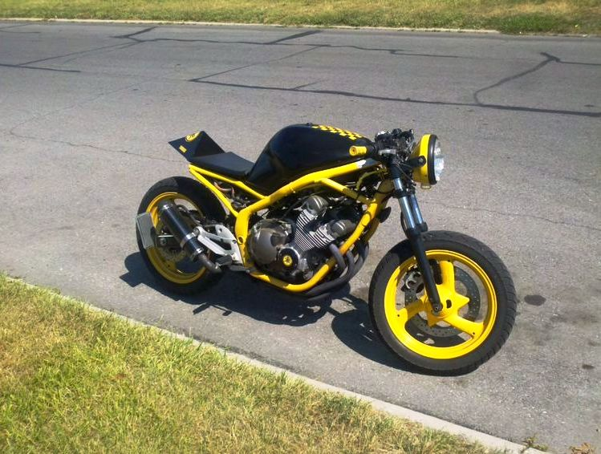
Greeny4704’s 1995 XJ600N Streetfighter

SunMonTueWedThuFriSat12345678910111213141516171819202122232425262728293031
2013
October

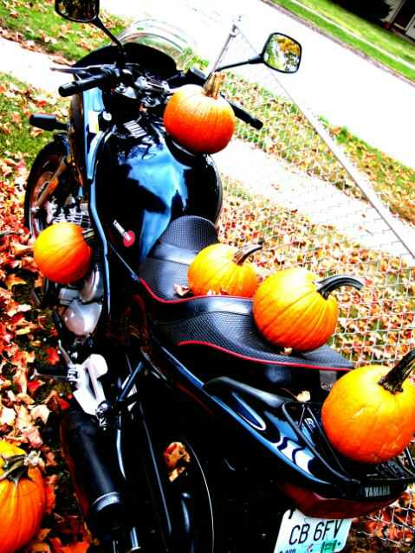
MozarkRider’s 1992 XJ600S (Seca II)

SunMonTueWedThuFriSat123456789101112131415161718192021222324252627282930
2013
November

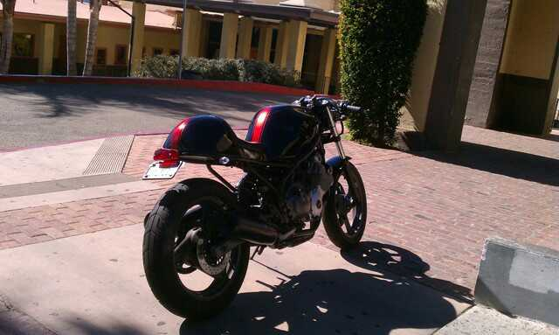
Bhppy101’s 1993 XJ600 Cafe

SunMonTueWedThuFriSat12345678910111213141516171819202122232425262728293031
2013
December

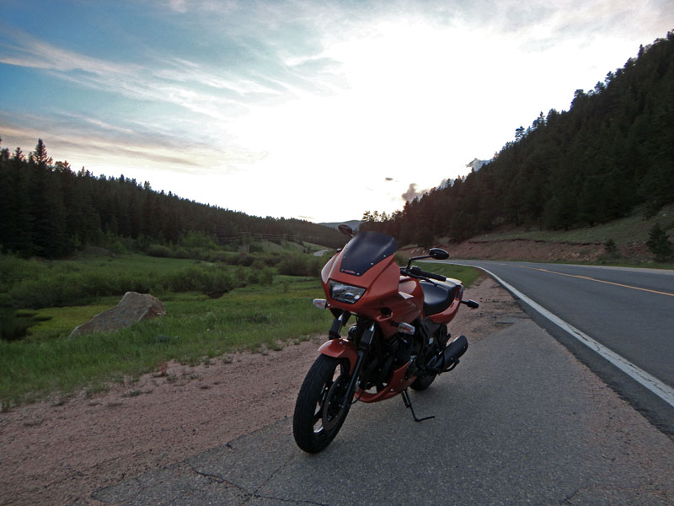
Radare’s 1997 XJ600S (Seca II)

